# Modeling the Interactions in a Nucleus

# Part of a Series of Activities related to Plasmas for Middle Schools

**Robert Reiland, Shady Side Academy, Pittsburgh, PA**

Chair, Plasma Activities Development Committee of the Contemporary Physics Education Project (CPEP) and Vice-President

**Cheryl Harper, Greensburg Salem High School, Greensburg, PA**

Chair of the Board, Contemporary Physics Education Project

**Editorial assistance:** **G. Samuel Lightner,** Professor Emeritus of Physics Westminster College, New Wilmington, PA and Vice-President of Plasma/Fusion Division of CPEP

Based on the CPEP activity: *Long Range Repulsion, Short Range Attraction*

originally authored by

**Robert Reiland**, Shady Side Academy, Pittsburgh, PA

with editorial assistance from

**G. Samuel Lightner**, Professor Emeritus of Physics Westminster College,

**Ted Zaleskiewicz**, Professor Emeritus of Physics,

University of Pittsburgh at Greensburg,

President Emeritus, Contemporary Physics Education Project

Prepared with support from the Department of Energy,

Office of Fusion Energy Sciences,

Contract # DE-AC02-09CH11466

© Copyright 2021 Contemporary Physics Education Project www.CPEPphysics.org

**Preface**

This activity, produced by the Contemporary Physics Education Project (CPEP), is intended for use in middle schools. CPEP is a non-profit organization of teachers, educators, and physicists which develops materials related to the current understanding of the nature of matter and energy, incorporating the major findings of the past three decades. CPEP also sponsors many workshops for teachers. See the homepage [**www.CPEPphysics.org**](http://www.CPEPphysics.org) for more information on CPEP, its projects and the teaching materials available.

This activity packet consists of the student activity followed by notes for the teacher. The Teacher’s Notes include background information, equipment information, expected results, and answers to the questions that are asked in the student activity. The student activity is self-contained so that it can be copied and distributed to students. Page and figure numbers in the Teacher’s Notes are labeled with a T prefix, while there are no prefixes in the student activity.

**The Student Section of this Activity is structured on the BSCS 5E model of instruction.**

The following description of the 5E model is excerpted from the Introduction to the BSCS text: *BSCS Science: An Inquiry Approach*

***Engage***

***Explore***

***Explain***

***Elaborate***

***Evaluate***

According to the BSCS 5E model, each “E” represents and important part of the sequence through which students progress to develop their understanding. First, students are *engaged* by an event or a question related to a concept, and they have opportunities to express their current understanding. Then they participate in one or more activities to *explore* the concept and share ideas with others before beginning to construct an explanation. Following the initial development of an explanation, students have the opportunity to *elaborate* and deepen their understanding of the concept in a new situation. Finally, students *evaluate* their growing understanding of the concept before encountering a new one. The combination of the 5E model with a strong assessment-oriented design provides opportunities for learning and conceptual change in students, which leads to an improved understanding of science (Bransford, Brown, & Cocking, 2000).

**Modeling the Interactions in a Nucleus**

**Part of a Series of Activities related to**

**Plasmas and the Solar System**

**for Middle Schools**

Set-up:

Your teacher will organize you into groups of three or four and distribute to each group sets of material which you will use to investigate models of real physical situations.

Set #1: A set of magnets with poles marked (colored)

Set #2: A set of magnets with Velcro on one end

Set #3: “Magnets on a rod” assembly

**ENGAGE Procedure – using the set of magnets with poles marked** (Set #1)

Note that your magnets are marked differently on the two ends. Try different combinations when bringing the ends near or together.

Based on your observations, discuss the following with your group and write down your answers to the following questions:

* 1. When do the magnet ends repel?
  2. When do the magnet ends attract?
  3. When is the push/pull the strongest?
  4. When is the push/pull the weakest?

During a class discussion, share your answers with your class.

**EXPLORE Procedure – using the set of magnets with Velcro sides** (Set # 2)

You have a second set of magnets that look like the first set, except that each of these magnets has Velcro on the ends. Note that the magnets have different Velcro on each end.

Try different combinations when bringing them near or together.

Based on your observations, discuss the following with your group and write down your answers to the following questions:

* 1. Do the magnets with Velcro still repel? When?

* 1. Do the magnets with Velcro still attract? When?
  2. Are there any differences in the attraction or repulsion compared to the plain (without Velcro) magnets?
  3. What can happen now because of the Velcro?

During a class discussion, share your answers with your class.

**EXPLAIN Procedure**

When you create a model you are representing a situation with something else that has similar characteristics. The physical situation you are modeling is the interactions in an atomic nucleus.

You may know some things about the structure of an atom. Fill in the blanks below with the appropriate answers using previous knowledge or research the answers if needed.

1. An atom has a _________ charged, dense center portion called the nucleus, which is surrounded by negatively charged particles called ____________.
2. In the nucleus are two types of particles called __________ and _________.
3. The ______________ have a positive electric charge.
4. The ______________ are neutral.
5. Objects that have opposite electric charge (attract) (repel) each other.
6. Objects that have the same electric charge (attract) repel) each other.
7. So…protons (attract) (repel) other protons.

Now consider the following questions:

Since a nucleus consists of neutrons and protons, explain why a nucleus should not stay together.

But a nucleus does stay together. How might this happen?

With this activity, you have tried to model what happens in the nucleus of an atom. Think back to your observations with the magnets with Velcro. , did you still feel repulsion?

When you brought the similar sides (poles) of the magnets together, could you get them to stick together? If so, when?

There were actually two interactions at work with the Velcro magnets: the magnetic interaction (part of the electromagnetic interaction) and the Velcro interaction. Inside the nucleus of an atom, there are also two interactions at work. One is the electric interaction and one is the strong nuclear interaction.

In our model, which interaction (magnetic or Velcro) represented the electric repulsion of protons in the nucleus?

In our model, which interaction (magnetic or Velcro) represented the strong nuclear attraction of protons in the nucleus?

According to your model, which interaction in the nucleus (electric or strong nuclear) acts over larger distances?

According to your model, which interaction in the nucleus (electric or strong nuclear) only acts when the objects are very close together?

**ELABORATE Procedure**

Using our magnets, we can also model what might happen when two separate nuclei interact. Recall that a nucleus is made up of protons and neutrons. Does a nucleus have an electric charge? If so, is it positive or negative?

In the Explain section, you observed that even though protons repel, the nucleus stayed together because of a second interaction, the strong nuclear interaction. Would you expect that you could get two nuclei to "stick together"? Why or why not?

Observe the “magnets on a rod” assembly (Set #3). The similar sides (poles) of the magnets have Velcro glued to them. Do the similar sides attract or repel?

Is this consistent with the observations you made earlier in the *explore* procedure?

Now shake the rod back and forth. Can you get the pieces to attract and stay together?

In your model for this exercise, what do the repelling magnets represent? How is this similar and how is this different from what they represented in the model of the nucleus in the Explain section?

In your model for this exercise, what does the Velcro interaction represent? How is this similar and how is this different from what it represented in the model of the nucleus in the Explain section?

Why did you need to shake the magnets in order to get the magnets to stick together? What might the shaking represent in your model?

**Nuclear Fusion**

You may have heard about nuclear fusion. In this section you modeled the fusion process. In the fusion process, two smaller nuclei fuse and become one larger nucleus. This means that even more protons may need to stick together. This process is capable of releasing a considerable amount of energy.

Refer to a copy of the chart, *FUSION: Physics of a Fundamental Energy Source*. As you look over the chart, you will see descriptions and graphics of many physical science topics. Some of the topics you will study in high school or possibly in college. Some topics are appropriate for your current grade level. In particular find the block towards the center entitled: TWO IMPORTANT FUSION PROCESSES.

The process on the right in the block: “p-p” SOLAR FUSION CHAIN (Figure 1) is the rather complicated process which generates the majority of energy given off by our Sun. You may study this process during high school or if you should go on to college.

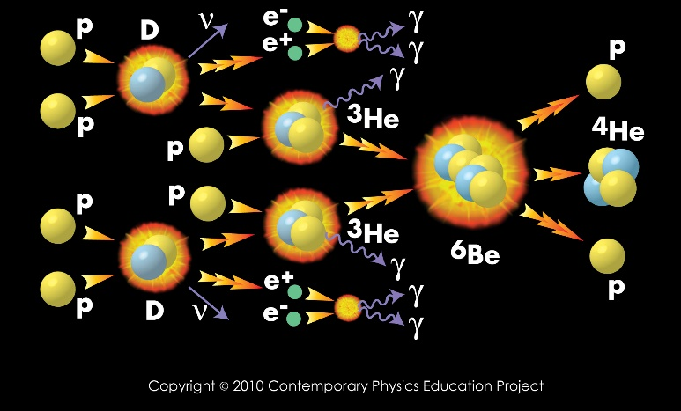

**Figure 1**: The “p-p” solar fusion chain

The process on the left in the block is D + T = 4He + 1n (Figure 2)

**Figure 2**: The “D+T” Reaction

**Reactants Fusion Products**

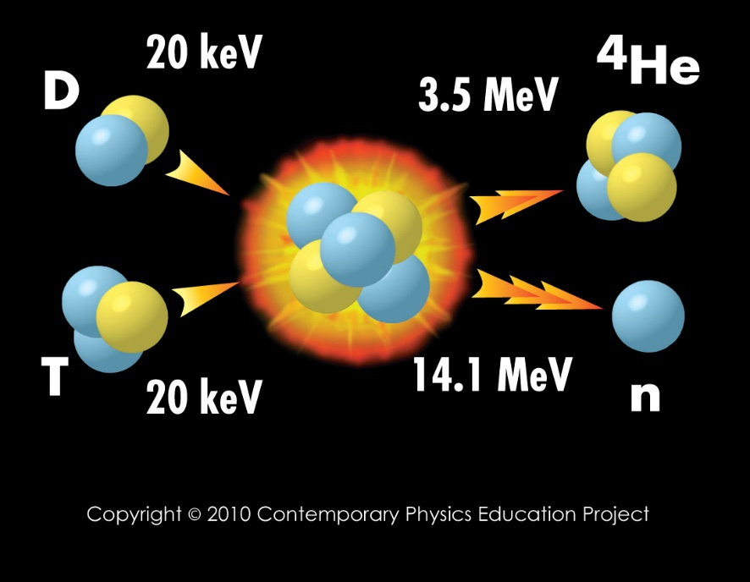

It is much simpler than the “p-p” fusion chain and is the reaction that will most likely be used in the first fusion reactors to generate electricity on a commercial basis.

This reaction is sometimes referred to as simply the “D + T” reaction.

What do the symbols D and T represent?

D and T represent the nuclei of two different types of hydrogen. Remember that hydrogen is the simplest type of atom and that a hydrogen atom will ALWAYS have only one proton. The most common type of hydrogen atom has a proton (p) for its nucleus and no neutrons. This type of hydrogen is sometimes written as 1H. The ‘1’ tells us that there is one thing in the nucleus, a single proton.

Another type of hydrogen can have one proton as well as one neutron in the nucleus. This is called deuterium and the nucleus is called a deuteron, D, and it is sometimes written as 2H. The ‘2’ tells us that there are two things in the nucleus (one proton and one neutron). It is still a type of hydrogen since it contains only one proton. Look at the D+T graphic on your chart and locate a D.

Another type of hydrogen can have one proton as well as two neutrons in the nucleus. This type of hydrogen is called tritium and the nucleus is called a triton, T, and it is sometimes written 3H. The ‘3’ tells us that there are three things in the nucleus (one proton and two neutrons). Since there is only one proton, we know that this is still a type of hydrogen. Look at the D+T graphic on your chart and locate a T.

The D and T each have one proton, but they have different numbers of neutrons: D has one and T has two. When nuclei contain the same number of protons, but different numbers of neutrons they are called *isotopes*. The number of protons determines the type of atom, and since both the D and T have one proton they are both types of hydrogen.

Figure 3 may help you visualize the three isotopes of hydrogen.

**Figure 3**: The three varieties (isotopes) of a hydrogen nucleus

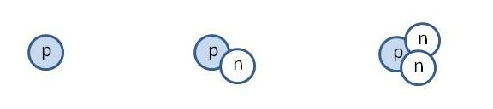

Common Deuterium Tritium

Hydrogen Nucleus Nucleus

Nucleus (Deuteron) (Triton)

What does the symbol 4He represent?

He stands for helium and this is another type of atom. EVERY helium atom will have two protons. 4He is a helium nucleus and the ‘4’ tells us that it contains four things inside of the nucleus. Since we know that helium must have two protons, then 4He must have two protons and two neutrons in the nucleus. It is sometimes called an alpha particle, . Look at the D+T graphic on your chart and locate an  (4He).

What does the symbol 1n represent?

‘1n’ stands for a neutron. The ‘1’ tells us that there is one thing in the nucleus: a neutron. So 1n represents a single neutron. Look at the D+T graphic on your chart and locate a 1n.

Using the pictures from the *Fusion: Physics of a Fundamental Energy Source* chart, Figure 3, and the definitions above, fill out the following table:

|  |  |  |  |
| --- | --- | --- | --- |
| Symbol | Number of protons | Number of neutrons | Is this a type of hydrogen? |
| D |  |  |  |
| T |  |  |  |
| 2H |  |  |  |
| 3H |  |  |  |
| 4He |  |  |  |
|  |  |  |  |
| 1n |  |  |  |
| 1H |  |  |  |

When you look at the D+T graphic you can see that a D and a T combine to create a large nucleus. That large nucleus is not stable so it then breaks apart into a 4He and an n.

The graphic for the D + T reaction (Figure 2) shows that the  carries off 3.5 MeV of energy and the n carries off 14.1 MeV of energy, for a total energy of 17.6 MeV. (MeV is a unit of energy used by nuclear scientists). This graphic shows that energy is released and carried off by the alpha particle and the neutron.

Where does this energy come from in the real D + T reaction?

The energy arises from the conversion of mass to energy according to the famous equation,

E = mc2.

Where: m = mass of (D + T) – mass of   + 1n)

c = the speed of light

E = energy released

How do you get the D and T close enough to fuse?

The positively charged nuclei repel so how do we get them close enough for the strong nuclear interaction to cause them to fuse (represented by the repelling magnets and the attractive Velcro in our model)? In our model we shook the magnets until they got close enough for the Velcro to "grab". Did you say that this represented adding energy to the nuclei to get them moving faster, and that you would get them moving faster by increasing their temperature? The temperature must be about 100 million degrees!

This presents another problem. If the nuclei are heated enough to get them moving this fast, it is hard to keep the nuclei together. They want to fly all over the place. You must have some way to keep them together, to confine them. In our model, how did you confine the "nuclei"?

On the bottom of the chart in the center there is an area called **Creating the Conditions for Fusion, Plasma confinement and heating** which shows several ways to confine the nuclei. Inertial Confinement and Magnetic Confinement are two ways to confine a fusion reaction. Your teacher may provide you with more information about these two techniques if he/she feels it is appropriate

**EVALUATE Procedure (what works and what doesn’t in the models?)**

You have now studied models of interactions in a nucleus and of interactions between nuclei. In the first model the magnets with Velcro represented the protons in a nucleus and in the second model the magnets with Velcro represented different nuclei.

As a review, in these models, what did the similar magnetic poles specifically represent?

And what did the Velcro represent?

How well did these models represent the actual physical situation? That is, how were these interactions (magnetic and Velcro) similar to the interactions (electrical and nuclear strong) in an actual nucleus or between two nuclei? How did they differ?