Plasma Globes and “Body Capacitance”

## Part of a Series of Activities in Plasma/Fusion Physics

**to Accompany the chart**

### *Fusion: Physics of a Fundamental Energy Source*

**Robert Reiland, Shady Side Academy, Pittsburgh, PA**

Chair, Plasma Activities Development Committee of the

Contemporary Physics Education Project (CPEP)

#### Editorial assistance: G. Samuel Lightner, Westminster College, New Wilmington, PA and Vice-President of Plasma/Fusion Division of CPEP

Advice and assistance: Cheryl Harper, Greensburg-Salem High School, Greensburg, PA and Chair of the Board of CPEP; T. P. Zaleskiewicz, University of Pittsburgh at Greensburg (emeritus), Greensburg, PA and President of CPEP

Prepared with support from the Department of Energy, Office of Fusion Energy Sciences, Contract #DE-AC02-76CH03073.

©2021 Contemporary Physics Education Project (CPEP) www.CPEPphysics.org

Plasma Globes and “Body Capacitance”

## Part of a Series of Activities in Plasma/Fusion Physics

**To Accompany the chart**

### *Fusion: Physics of a Fundamental Energy Source*

**Introduction and General Background:**

Plasma globes are fun to watch, with their colorful, spark-like streamers. One thing you quickly learn with a plasma globe is that when you put your hand on it, the streamers are concentrated near your hand. A major goal of these activities is to understand how the electrical spark-like streamers in plasma globes form and why they are concentrated near wherever you place your hand. To do so, we must understand how sparks form, and the role of a human body in helping to produce or in affecting the locations of these electrical sparks and streamers.

Sparks are very common. Most of us have accidentally encountered electrical sparks on dry days as we walk along a carpet and then get shocked as we reach toward something metallic. Sometimes a person will get out of a car and get shocked as he or she touches the outside of the metal door. Sparks jumping from clothes that have been dried in a clothes dryer are also common. The streamers in plasma globes are like sparks in air, and, as with other sparks, form in response to the building up of opposite electrical charges.

While a more detailed knowledge about insulators, conductors, electrical charges, voltage and electric fields may be required for a complete understanding of the formation of sparks, a simple idea can aid in understanding both how electrical sparks form and the concentration of electrical streamers inside a plasma globe. This idea is that when small electrically charged particles, for example either electrons or positive “ions,” bunch up together in an object, such as at the end of a finger about to reach a light switch, the “like charges” in the bunch repel one another and any like electrical charges in the air near the object, and also they attract opposite charges. These repulsions and attractions can sometimes push charges off surfaces. Even when this doesn’t happen, the repulsions and attractions of charges in air can sometimes produce sparks. The charges may bunch up on “insulators,” objects made of material through which electrical charge will not easily move, but the sparking usually occurs between “conductors,” through which some electrical charges can easily move.

When asked why plasma globe streamers can be concentrated by placing a hand on the globe, physicists often say that it happens because of “body capacitance,” a term with meaning to those who’ve studied the physics of electricity and magnetism, but it is of little help to everyone else. It implies to those who understand the concept of capacitance, a particular process by which electrical charges become concentrated on the glass of the plasma globe near the hand. Capacitance is a measure of the ability to separate and store electrical charge. A capacitor is usually two conductors separated by some insulating material. Charges have to “bunch up” in order for us to see the effects of capacitance. In this activity we will see that a plasma globe can be considered a capacitor, and when you touch the globe, you become part of the capacitor

system. Hence the term “body capacitance.” When charges are separated within a material we say that it has been polarized. Here “separated” means that a small fraction of the negative charges in the material shift slightly to one side. This makes that side negatively charged and the side that the negative charges came from positively charged. Understanding how charges bunch up (polarize) will lead to an understanding of how the sparks/streamers form in a plasma globe and why your hand causes the streamers to concentrate.

**CAUTION**

In this activity you will be using a plasma globe and Tesla coil and a “grounded” wire. There are safety issues concerning these. A Tesla coil is a lot like the source of alternating electrical charge that is inside a plasma globe. It produces electrical charges that alternate sign typically over 10,000 times per second, and it does so at high voltages. These are typically in the range of 10,000 to 50,000 volts. This sounds extremely dangerous, but ordinarily it isn’t.

If the same voltages were produced at low frequencies or with direct current, they would be dangerous, but high frequency electricity does not penetrate far enough through human skin to where it could affect a person’s heart. It can produce a painful spark, but this will not result in injury unless it causes a person to move quickly away and to hit something hard.

An exception to this good news is that the electric fields radiating from a Tesla coil or plasma globe can interfere with the operation of an implanted defibrillator. If you have such an implant or if you have any heart problem at all, it will be safe for you to observe the activity from 2 or more meters away, but you should not operate the Tesla coil or touch the plasma globe. (This information was provided by private correspondence with a representative of Guidant Corporation, manufacturer of these implanted devices.)

Also an operating Tesla coil should never be brought near a person’s face. It should also not be brought near a plasma globe. Experience has taught us that a plasma globe can be destroyed by the sparks from a Tesla coil.

**Part I: Plasma Globe Streamers**

**Procedures:**

**First steps**

1. Plug in and turn on a plasma globe, and take some time to observe the apparent formation and disappearance of electrical streamers inside. Do you notice any patterns in the formation, motions and disappearances of streamers while nothing is in contact with the globe? For example, is there a particular region inside the globe where the streamers usually form? Is there a particular region in which they disappear? Do they tend to move up, down or sideways? Are the streamers usually straight or curved?
2. Place one of your hands on the side of the plasma globe. Does this affect the plasma streamers in any way? While keeping your hand on the globe, move it around. What do you see happening to the streamers? Place your hand on top of the globe. Are the effects here different in any way or ways from those that were produced with your hand on the side of the globe?
3. Instead of placing a hand on the plasma globe, try resting a variety of light non-metallic objects on the top of the globe. You might use sheets of paper, small blocks of wood, sheets or pieces of plastic. Do any of these produce the same effects you saw with your hand on the globe? Are the effects different when you are touching the objects with your hand? Does it matter whether this touching is close to or relatively far from the globe surface? In particular note any effects when the objects are held against the side of the globe, as opposed to the top. As a control, note exactly where your hand is in relation to the plasma globe while touching some of these objects and observing the effects, and remove the object while keeping your hand in the same location. Did it matter whether the objects were between your hand and the plasma globe?
4. Repeat Procedure # 3 with small sheets of aluminum foil.
5. Bring a metal object, such as a key or the point of a nail close to the foil that you just placed on top of the plasma globe, but don’t let it touch the foil. Can you get a spark to form between the foil and the metal object? When this happens, is there a streamer on the other side of the glass? Is there ever a spark in the glass itself? Note that, if the key you are using has a plastic handle, you may have trouble producing a spark unless you are careful to hold onto the metal part of the key rather than the plastic handle.

For the rest of this part, you will examine the effects of conductors, such as your hand and metal sheets, on sparks and electrical streamers with the goal of finding ways to reproduce effects like those produced by your hand on the plasma globe under controlled conditions. The results that you get will form the bases of more focused investigations in Part II of capacitance.

**Follow-up steps:**

You probably saw little to no effect on the streamers from the objects used in Procedure # 3, unless you had your hand very close to the globe. You probably saw the biggest effects in Procedure # 4 when you were touching the foil that was on the surface of the plasma globe. Somehow the combination of metallic material, such as aluminum foil, and a connection to something relatively large, like your body, produces a relatively large effect. In the next procedures, you will determine whether the sizes of these effects depend more on the surface area of metal on the globe or the mass of what’s on the globe. Possibly, both factors are important.

1. Cut out two roughly square sheets of aluminum foil. One should be about an inch across, and the other should be about 6 inches across. Place one on top of the plasma globe, and smooth it down to match the curvature of the globe. Observe any differences between the streamers with and without this sheet of foil. Repeat with the other sheet of foil. Next, observe any new effects if you are making contact using one finger on the foil. Do this in turn with each sheet of foil. Does the size of the foil make any difference?
2. Repeat procedure 6 with the sheets of foil held to the side of the globe with a moderately long insulator, such as a Popsicle stick.
3. Replace the small sheet of foil with a coin of similar area. Typically, this would be a quarter. Is there any significant difference between the effects with the small sheet of foil and the coin when you touch neither? Is there any significant difference between the effects with the small sheet of foil and the coin when you touch both? Compare the effects in the same way between the large sheet of foil and the coin.
4. Examine the glass just inside of any metal you have placed on the globe. Note the additional illumination of the glass when you touch the metal with a finger or your hand. Now place the large sheet of foil on the globe and observe the brightening of the glass on the inside. Does this brightening occur at all points across from the foil, as it did with metal of smaller area, or is it more limited? Next place all fingers and the palm of one hand on a side of the globe and answer the same questions. Remember these observations as you observe the object made of cardboard and foil in the next part.

**Questions:**

1. From this activity and previous experiences, do you think that the electrical streamers in a plasma globe and sparks in general are attracted to everything placed on or near the globe? Are there materials that attract streamers and sparks better than other materials? What is the evidence for your answer?
2. You may have noticed that the streamers tend to disappear near the top of the globe, but streamers stay near the top when your hand is on top of the globe or when a conductor is there while your hand or finger is in contact with the conductor. Steamers are formed when there is a difference in concentrations of electrical charge between two points. They form more readily in gases that are more easily ionized, such as gases at lower densities. Does placing your hand on the globe have more of an effect on the electrical charge difference between the ball at the center of the globe and the glass globe or on the ease of ionizing the gas in between central ball and outer glass globe? In answering this, think about where the hand is and what it could most easily affect.
3. Is the area of a conductor (metal or hand) in contact with the outer surface of the plasma globe or the mass of this conductor more important in keeping streamer close to the part of the glass just inside the conductor?
4. The ball inside a plasma globe is made to alternate sign of electrical charge typically over 10,000 times per second. If an electrical streamer forms between this ball and the inside of the enclosing glass, is it likely that the inside surface of the glass stays electrically neutral while the streamer is present? For example, if the ball has just turned positive, is it likely that the inside of the glass is becoming positive or negative or that it is remaining neutral? In answering this, think about what you know about polarization of electrical charges in materials. Draw a picture of what you think happens in the glass.

1. Do you ever see sparks forming within the glass of the plasma globe? Can electrical charge make its way through the glass? If it can’t, and if sparks form on the outside of the globe, between a sheet of foil or a metal object, there must be something that does get through the glass that can affect electrical charge. This something is called an electric field. What characteristics should an electric field have to explain its ability to generate sparks?
2. Considering your answers to the previous four questions, when there is a relatively large conductor on the outside surface of the glass of an operating plasma globe, how might this affect the charges on the inside of the globe? At this point you are hypothesizing. It is not important that you get this right or that you fully understand what the causes are of the observed and hypothesized effects. You will be starting the final activity in this set with the hypothesis that you have just written down and possibly with others from other students. You may even develop more hypotheses as you proceed. Eventually you will likely eliminate all but one of these hypotheses as you develop a better understanding of what happens inside a plasma globe.

**Part II: Plasma Globe Streamers and Capacitance**

The primary reason for this part of the activity is to develop an understanding of how placing something like your hand on the outside of a plasma globe can affect what happens inside the globe. In order to do this you will construct something relatively simple that can be used to produce similar effects under controlled conditions. You will make comparisons between what happens with your construction and with a plasma globe.

**Procedures:**

1. Draw circles of the same size on both of two cardboard sheets. These circles should be at least 6 inches in diameter and can be drawn by placing a small plate or similar sized circular object on a sheet and tracing around it. Cut the cardboard circles that you’ve drawn. Place one cardboard circle on top of the other, pick a point that looks close to the center of the circle and push one metal tack through both cardboard circles at this point. Separate the two circles, leaving the tack in one, and push another tack into the other circle at the hole that was just made.
2. Cut out two sheets of aluminum foil that are both slightly wider than the diameters of the cardboard circles that you made. Place one over each cardboard circle on the side with the rounded part of the tack. Fold over the excess foil flush with the other side of the cardboard circle to hold the foil in place. Smooth the foil on both sides of the cardboard as flat as possible. It is particularly important that the foil make contact with the rounded part of the tack. (See Figure 1)

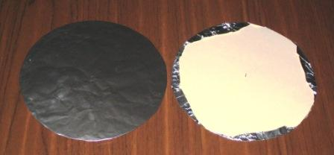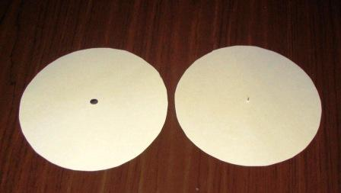

Cardboard circles with aluminum foil

Cardboard circles showing tacks

Figure 1

1. Cut two pairs of narrow slits on opposite sides of a shoe box as shown in the picture below. The slits should be just wide enough for one of the foil covered cardboard circles that you just made to rest in vertically. Slits on the same side of the box should be between two and three centimeters apart. (See Figure 2)

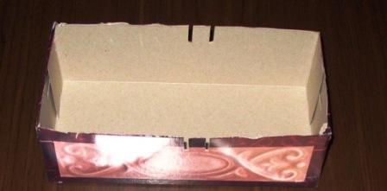

Cardboard box support for two cardboard circles

Figure 2

1. Place the two foil covered cardboard circles in the slits of the box so that the foil parts face one another and the points of the tacks are to the outside. (See Figure 3) You have now made a type of capacitor, and you will use it to test hypotheses about the formations of electrical sparks and streamers.

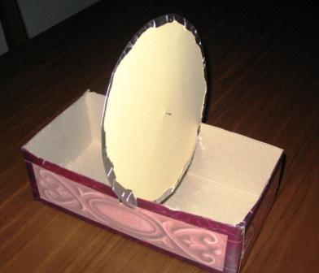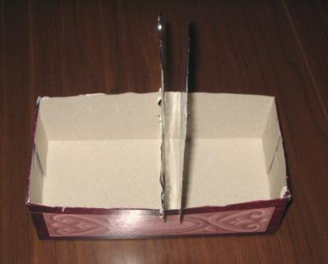

Foil covered cardboard circles mounted in the box

Figure 3

**Note on ground wires:** A ground wire will have one end connected to the largest chunk of metal available. The wire can be any metal wire or set of metal wires connected, end-to-end. The basic idea behind a ground wire or the general concept of an electrical “ground” is that it is something that is connected to a relatively large electrical conductor that can supply or absorb quantities of electrical charge larger than what will be supplied by any electrical device. In the most literal sense, it is the “ground” of the Earth or any set of connected conductors that have some contact with the ground of the Earth. This works because the ground is a moderately good conductor and it is so large that it can easily absorb or supply any amount of electrical charge that would be needed to neutralize any manufactured electrical device.

Good options for something to ground one end of the ground wire to are any metal water pipes (gas pipes are not a good idea), a metal desk or a metal radiator.

1. Plug in the Tesla coil and adjust it until you can feel it vibrating lightly. At this time, if the point of the Tesla coil isn’t near anything, there should be no noticeable sparks. Yet the pointed end of the Tesla coil is reversing electrical charges over 10,000 times per second! You might then wonder why there are no sparks. Move the point of the Tesla coil near a variety of different objects. You should see that sparks are formed between the point of the Tesla coil and many of the things it gets close to, but also look for cases in which the sparks are longer or thicker than in other cases and note if there are objects or materials near which the Tesla coil can’t form sparks at all. Be sure to try glass and plastic objects as well as metal objects.
2. Remove one of the cardboard circles from its slot. Bring the point of the Tesla coil near the tack point of the remaining cardboard circle, which is still in a shoebox slot. How does the size of the resulting spark compare to those you found when you brought the point near to nonconducting objects? In particular what is the largest distance or gap between the point of the Tesla coil and the tack point that can be bridged by a spark?
3. Bring the point of the Tesla coil near the free end of the grounded wire, and note the size of the largest spark that forms. How do they compare to sparks observed in part 6?
4. Replace the second foil-covered circles in its shoebox slots and make sure that the tack points are outward and the foil surfaces are parallel and not touching. Bring the free end of the grounded wire near to one tack point and bring the point of the Tesla coil near to the other tack point. You should see sparks from the tack points on both sides and no sparks between the parallel sheets of foil. If any sparks form between the parallel sheets of foil, adjust the strength of the Tesla coil down and try again until you get no sparks between the foil sheets but still get sparks from the tack points. Note the sizes of the sparks between a tack point and the Tesla coil and between the other tack point and the end of the grounded wire. How do these sparks compare to those that you saw in the previous three procedures? If you had to reduce the electrical output from the Tesla coil in this procedure, quickly redo the tests from the previous three procedures for better spark size comparisons. You should see relatively large sparks from the tack points on both sides.

**Questions:**

1. The Tesla coil doesn’t produce sparks unless there is something close to its point. Does the size of the spark depend on whether the object is a conductor (usually something metal, but the human body is a conductor at the voltages involved) or a nonconductor? Does the size of the spark depend on whether the part nearest the Tesla coil is sharp or flat? Does the size of the spark depend on whether or not the object the Tesla coil is brought near is grounded?
2. Consider the air gap between the sheets of foil in your capacitor as like the glass of a plasma globe in that both are nonconductors. You may have been uncertain about whether or not sparks were going through the glass, but now you’ve seen that sparks can form on both sides of your capacitor without sparks going through the air between the sheets of foil. Use the following illustrations of a capacitor and of a plasma globe to model what happens to an operating plasma globe. Specifically, identify and label the parts of the capacitor that correspond to the following parts of a plasma globe: The central ball that all of the streamers seem to come from, the streamers, the glass and your hand. Note that one thing seems to be missing in the plasma globe system. That is a second set of streamers or sparks. This could be produced by replacing the hand with foil on the outside of the glass and moving your hand so that it doesn’t quite touch this foil. If you want to try this modification, be prepared for a small shock. What do you think is happening to your body when your hand is brought near an operating plasma globe?

Tesla coil

Ground

wire

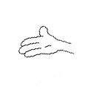

1. How is your hand like a grounded conductor? Has your body become part of the “capacitor”?
2. In Part I you probably noticed that the illumination on the inside of the glass of the plasma globe didn’t occur everywhere that your fingers and palm touched when you had your entire hand on the glass. Also the illumination probably shifted around to areas near different parts of your hand. Relate this to the fact that sparks did not form between the sheets of aluminum in the capacitor you constructed. Think in terms of how much charge is polarized per area when the area is large.
3. You have investigated how the effects with your capacitor depend on whether or not grounding is involved. Use these results to try to explain how electrical streamers inside a plasma globe are strengthened when you have a hand on the globe.