**Resistance of a Fluorescent Bulb**

**Plasma Tube with Power Supply Version**

## Part of a Series of Activities in Plasma/Fusion Physics

**to Accompany the chart**

### Fusion: Physics of a Fundamental Energy Source

**Teacher’s Notes**

**Robert Reiland, Shady Side Academy, Pittsburgh, PA**

Chair, Plasma Activities Development Committee of the

Contemporary Physics Education Project (CPEP)

#### Editorial assistance: G. Samuel Lightner, Westminster College, New Wilmington, PA and Vice-President of Plasma/Fusion Division of CPEP

Advice and assistance: T. P. Zaleskiewicz, University of Pittsburgh at Greensburg (emeritus), Greensburg, PA and President of CPEP; Cheryl Harper, Greensburg-Salem High School, Greensburg, PA and Chair of the Board of CPEP; Todd Brown, University of Pittsburgh at Greensburg, Greensburg, PA, and associate member of CPEP

Prepared with support from the Department of Energy, Office of Fusion Energy Sciences, Contract #DE-AC02-76CH03073.

©2021 Contemporary Physics Education Project (CPEP) www.CPEPphysics.org

Preface

This activity is intended for use in high school and introductory college courses to supplement the topics on the Teaching Chart, ***Fusion:***  ***Physics of a Fundamental Energy Source,*** produced by the Contemporary Physics Education Project (CPEP). CPEP is a non-profit organization of teachers, educators, and physicists which develops materials related to the current understanding of the nature of matter and energy, incorporating the major findings of the past three decades. CPEP also sponsors many workshops for teachers. See the homepage [**www.CPEPphysics.org**](http://www.CPEPphysics.org) for more information on CPEP, its projects and the teaching materials available.

This activity packet consists of the student activity followed by some general background information and then notes for the teacher. The Teacher’s Notes include background information, equipment information, expected results, and answers to the questions that are asked in the student activity. An appendix to the Teacher’s Notes shows the alignment of the activity with the National Science Standards and with the AAAS Benchmarks. The student activity and general background are self-contained so that they can be copied and distributed to students. Page and figure numbers in the Teacher’s Notes are labeled with a T prefix, while there are no prefixes in the student activity. The page number and figures in the separate background section are labeled with a B prefix.

Developed in conjunction with the Princeton Plasma Physics Laboratory and funded through the Office of Fusion Energy Sciences, U.S. Department of Energy, this activity has been field tested at workshops with high school and college teachers.

We would like feedback on this activity. Please send any comments to:

Robert Reiland

Shady Side Academy

423 Fox Chapel Road

Pittsburgh, PA 15238

e-mail: robreiland1@comcast.net

voice: 412-968-3049

**Resistance of a Fluorescent Bulb**

**Plasma Tube with Power Supply Version**

**Teacher’s Notes**

## Part of a Series of Activities in Plasma/Fusion Physics

**to Accompany the chart**

### Fusion: Physics of a Fundamental Energy Source

**Introduction:**

This activity was originally designed to be a companion to the Plasma/Fusion activity “Properties of a Plasma: Half-Coated Fluorescent Bulbs”[1]* and to use the half-coated bulb from that activity. However, it can also be a “stand-alone” activity with a standard fluorescent bulb such as the "plasma device" as listed below. The student part of this activity assumes this "plasma device." This activity can also be used with a unit or course on electrical circuits. In addition, it can be used to study the electrical properties of plasmas under controlled conditions.

**Equipment List:**

Plasma Device (A clear fluorescent tube built into a power supply with adjustable voltage and measurement points) See Circuit diagram, provided by Alexander Nagy with General Atomics, in Appendix A.

Tesla Coil

Science KIT 61157-02 (or equivalent)

Digital Multimeter (preferably TWO of these)

(Science KIT 64971-02 or equivalent)

**Comments on light bulbs versus fluorescent bulbs and V vs. I graphs:**

In a common activity to study electrical resistance in light bulbs, students measure voltages across and currents through ordinary light bulbs as they vary the voltage. By comparing their graphs of voltage versus current to the same kinds of graphs produced with commercial resistors, they find that while the slope of voltage versus current for a commercial resistor is constant with an intercept of zero (direct proportionality) and indicative of a constant resistance equal to the slope, the ratio of voltage to current for a light bulb becomes greater as the voltage is increased.

Usually you will have your students graph voltage versus current (voltage on the vertical axis and current on the horizontal axis) because the slope would have the units of electrical resistance. But recognize that voltage is really the independent variable and would normally be placed on the horizontal axis. In other words the physics is to understand how current is produced by voltage across the system in question and why the current increases with increasing voltage in the particular way it does for each type of system.

When students take the same types of measurements with a fluorescent bulb, they will find that the ratio of applied voltage to resulting current decreases with increasing applied voltage. It is then clear that different things are happening with commercial resistors, light bulbs (actually, the metal wire of the filament) and fluorescent bulbs. When the voltage is increased across a fluorescent bulb, the effects start out the same as those produced by a voltage increase across a metal wire. Electrons and ions that are mobile in the plasma in the fluorescent tube gain energy and then quickly lose much of it by scattering off other ions and electrons and also by scattering off neutral atoms. But there are two additional processes occurring in the plasma that do not normally occur in a metal wire. One is that electrons and ions that lose enough energy in these collisions may recombine to form neutral atoms. The other is that electrons and ions that gain enough energy between collisions from the applied voltage may ionize neutral atoms to form new electrons and ions. At a given voltage these opposing processes achieve a dynamic equilibrium in which they occur at the same rate and keep the total number of current carrying electrons and ions fairly constant.

However, when the voltage is raised, electrons and ions can gain more energy between collisions, and with greater energy the chances decrease that recombinations will take place to form neutral atoms while the chances increase that the more energetic electrons and ions will ionize neutral atoms. These changes continue until a new equilibrium with more conducting charges (ions and electrons) is produced. This means that unlike the situation in a metal wire, the number of conducting charges doesn’t stay constant as the voltage increases. Instead the number of conducting charges increases with increasing voltage. The combination of more conducting charges and greater systematic motion of these charges with increasing voltage results in electrical currents much higher than would be expected in a commercial resistor.

Students may want to try to figure out how the three types of electrical systems (commercial resistors, light bulbs and fluorescent bulbs) differ and how these differences produce the different trends in the graphs. A brief explanation of the differences in these systems is given in the general background section.

Notes on the experimental set-up:

You will need a d.c voltmeter that can measure up to 20 V. Most multimeters have this range.

Two identical meters that can be hooked up to get simultaneous readings from which both voltage and current can be determined will produce slightly better accuracy and much faster data taking.

**Answers to Questions:**

1. Does the electrical resistance of a fluorescent bulb increase with increasing voltage, decrease or stay nearly the same?

***Answer:*** The current through a fluorescent bulb increases at a much greater rate than the rate of increase in voltage.  This means that the ratio of voltage to current decreases as voltage is increased.  Since this ratio equals the resistance of the bulb, resistance decreases greatly with increasing voltage.

2. Increasing voltage across a fluorescent bulb should increase the rate at which electrical charge carriers, electrons and positive ions, move in producing the measured electrical current. Considering the way and the amount in which the electrical current changes as the voltage is increased, does it seem likely that an increase in the rate of motion of the electrical charge carriers alone can account for the observed changes in electrical current? If not, what other factor or factors could be involved?

***Answer:*** Since the increase in systematic motion of the charge carriers is at best proportional to the increase in voltage, the increase in current is much too large to be accounted for by the increase in motion. The large increase in current is mostly due to an increase in the number of charge carriers with increasing voltage. Higher voltages literally mean more kinetic energy added to each charge carrier between collisions, and this greater kinetic energy results in higher rates of ionization of neutral atoms.

3. Assuming that any increase in current is due solely to an increase in the number of charges carriers, calculate the ratios of the number of charge carriers at each voltage you used to the number of charge carriers at the lowest voltage you used.

***Answer:*** If we pretend that the systematic motion of charge carriers is constant (the increases are small relative to the increases in current), all of the additional current would come from addition charge carriers. That means that each ratio of charge carriers would be the same as the corresponding ratios of electrical currents.

##### APPENDIX A

Circuit Diagram for Plasma Tube (clear fluorescent tube)

and Power Supply.

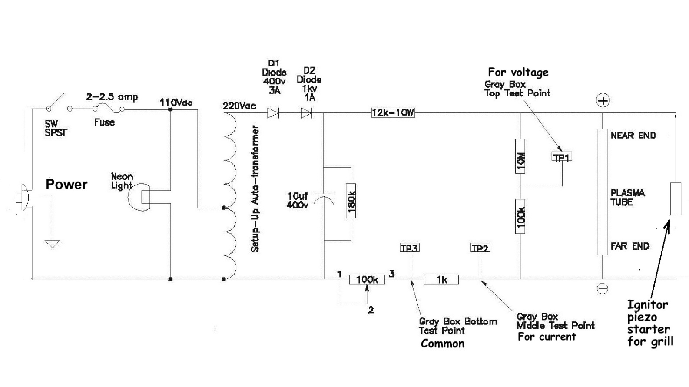

Provided by Alexander Nagy, General Atomics

## APPENDIX B

Alignment of the Activity

Resistance of a Fluorescent Bulb

with

Next Generation Science Standards

An abridged set of core ideas of the NGSS is shown below. An “x” represents some level of alignment between the activity and the specific standard.

|  |  |
| --- | --- |
| Next Generation Science Standards (abridged core ideas)  Grades 9-12 |  |
| Physical Sciences |  |
| PS1: Structure and Properties of Matter  “How can one explain the structure and properties of matter?” | X |
| PS2: Chemical Reactions  *“How do substances combine or change (react) to make new substances? How does one characterize and explain these reactions and make predictions about them?”* | X |
| PS3: Forces and Interactions  “How can one explain and predict interactions between objects and within systems of objects?” | X |
| PS4: Energy  “How is energy transferred and conserved?” | X |
| PS5: Waves and Electromagnetic Radiation  *“How are waves used to transfer energy and send and store information?”* | X |
| **Earth and Space Sciences** |  |
| ESS1: Earth’s Place in the Universe  *“What is the universe, and what is Earth’s place in it?”* | X |
| ESS2: Earth’s Systems  “How and why is Earth constantly changing?” | X |
| ESS3: Earth and Human Activity  *“How do Earth’s surface processes and human activities affect each other?”* |  |

While several standards may be included, the core ideas for Life Sciences and Engineering & Technology have not been listed.

The NGSS Practices and Crosscutting Concepts are integral to this activity:

**Practices:**

* Asking Questions
* Defining Problems
* Using Models
* Conducting Investigations
* Analyzing Data
* Using Mathematics
* Constructing Explanations
* Designing Solutions
* Arguing from Evidence
* Communicating Information

**Crosscutting Concepts:**

* Patterns
* Causation
* Scale
* Systems
* Energy
* Structure & Function
* Stability & Change

[*http://www.nextgenscience.org/*](http://www.nextgenscience.org/)

Alignment of the Activity

Resistance of a Fluorescent Bulb

with

AAAS Benchmarks

An abridged set of the benchmark is shown below. An “x” represents some level of alignment between the activity and the specific benchmark.

|  |  |
| --- | --- |
| AAAS Benchmarks (abridged)  Grades 9-12 |  |
| **1. THE NATURE OF SCIENCE** |  |
| *B. Scientific Inquiry* | X |
| **2. THE NATURE OF MATHEMATICS** |  |
| *B. Mathematics, Science, and Technology* | X |
| **3. THE NATURE OF TECHNOLOGY** |  |
| *C. Issues in Technology* |  |
| **4. THE PHYSICAL SETTING** |  |
| *A. The Universe* |  |
| *D. The Structure of Matter* |  |
| *E. Energy Transformations* |  |
| *F. Motion* |  |
| *G. Forces of Nature* | X |
| **11. COMMON THEMES** |  |
| *A. Systems* | X |
| *B. Models* | X |
| *C. Constancy and Change* | X |
| D. Scale |  |
| **12. HABITS OF MIND** |  |
| *B. Computation and Estimation* | X |

1. * Part of the series of activities in Plasma/fusion physics to accompany the CPEP chart *Fusion: Physics of a Fundamental Energy Source.*